**Four wheel OMNIDRIVE**

**1] what is omnidirectional wheels**

Omnidirectional wheel are based on a general principle : while the wheel proper provide traction in the direction normal to wheel axis , the wheels can slide in wheel axis direction without friction.

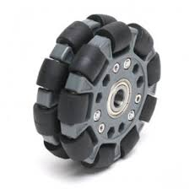

Note :

* To simplify the equations we will consider the instantenious acceleration and velocity of the drive(robot) with respect to its own refrence frame .

* translational velocity and angular velocity of the drive (robot) are known as Euclidean Magnitudes , which is different from individual motor speeds(velocity).

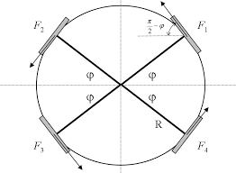

Fig.1

**ANALYSIS OF DYNAMICS**

* Now let us suppose the following necessary quantities –

“R” be the radius of the drive

“M” be the mass of the system (total load)

“a” be the total translational acceleration and ax and ay be the x and y component respectively.

“I” be the moment of inertia of the system about the centre of mass.

“F1,F2,F3,F4” be the force vectors as shown in fig.1

“f1,f2,f3,f4” the magnitude of the forces respectively.

“α” be the angular acceleration

“φ” be the angle as shown in fig.1

* It is clearly seen that

a = (1/M)*(F1+F2+F3+F4) [1]

α = (R/I)*(f1+f2+f3+f4) [2]

I = K*M*(R*R) [3]

Where, k is a constant (gyration constant)

* Now , we will write the equation for force in x and y direction .

M*ax = -f1sin(φ) – f2sin(φ) + f3sin(φ) + f4sin(φ) [4]

M*ay = f1cos(φ) – f2cos(φ) – f3cos(φ) + f4cos(φ) [5]

Substituting the value of I form [3] into [2],we get

Rα = (1/KM)*(f1+f2+f3+f4) [6]

Equations [4],[5]and [6] can be expressed in matrix form as follows

 = (1/M)* [A]

The matrix  is known as coupling matrix and is denoted by cα .

**Analysis of kinematics**

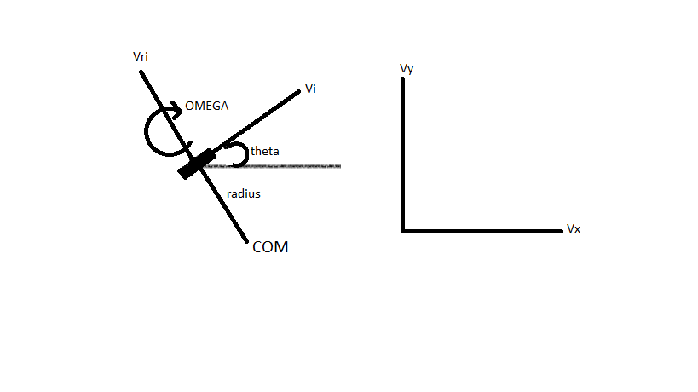 fig .2

* Now , let us soppose the necessary conditions for the anyalisis of the kinematics of the four wheel omnidrive.

“R” radius be the distance of the wheel from the centre of mass

“ω” omega be the angular velocity of the drive(robot)

“ϴi” theta be the angle made by a particular wheel with x-axis(ϴ1,ϴ2,ϴ3,ϴ4)

“Vi” be the transnational velocity of the ith wheel (V1,V2,V3,V4)

“Vri” be the roller velocity of the ith wheel (Vr1,Vr2,Vr3,Vr4)

“Vx” be the translational velocity of the drive(robot) in x direction

“Vy” be the translational velocity of the drive(robot) in y direction

* Correspondence between the Euclidean magnitudes and individual motor speed .

Vx + ωRcos(ϴi) = Vicos(ϴi) – Vrisin(ϴi) [1]

Vy = ωRsin(ϴi) = Visin(ϴi) + Vricos(ϴi) [2]

Now, by solving the above 2 equations, we get

Vxcos(ϴi) + Vysin(ϴi) + ωR = Vi [3]

{Vy + ωRsin(ϴi) – Visin(ϴi)}/cos(ϴi) =Vri [4]

Now by comparing fig.1 with fig.2 we can say that ϴi=90 - φi  
  
Representing the equation [3] in the matrix from

 =  [B]

The matix  is known as velocity coupling matrix and is represent by D.

**Analysis of acceleration**

let us do the naming of the above appeared matrices

a = 

f = 

m = 

v = 

so ,the above matrix equation [A] can be written as “a = Cαf”

similarly, the above matrix equation [B] can be written as “m = Dv”

* Now, we desire to find the values of ΔVi.

We have ΔV = Δt*a

Therefore ,

 = Δt*(DCα)*

DCα = (1/Mα)* + (1/M)*

Here, b= sin^2(φ) – cos^2(φ)